MS8401 (2022春)课程项目

危国锐 120034910021

（上海交通大学海洋学院，上海 200030）

摘要：.

关键词：词1，词2

Course Project

Guorui Wei 120034910021

(*School of Oceanography*, *Shanghai Jiao Tong University*, *Shanghai* 200030, *China*)

**Abstract****:** The purpose of this paper is to compare several commonly used classical decomposition (seasonal adjustment) methods systematically and to provide suggestions for future research.

**Keywords:** keyword 1, keyword 2

**目 录**

摘要 i

Abstract i

1 Introduction 1

2 Data and Method 1

2.1 Data 1

2.2 Classical decomposition 1

2.2.1 simple method 2

2.2.2 predictor-corrector method 2

2.2.3 global model fitting method 2

2.3 Experiment setup 2

2.3.1 idealized time series 2

2.3.2 real time-indices 2

2.4 Assessment methodology 2

2.4.1 idealized time series 2

2.4.2 real time-indices 3

3 Results 3

3.1 Idealized experiments 3

3.1.1 classical decomposition results 3

3.1.2 comparison of different methods 10

3.2 Classical decomposition of several real time-indices 12

4 Conclusions 12

References 12

# Introduction

A time series of a climate variable can be viewed as a single realization of a stochastic process that represents the mechanism generating it. One goal of the time-series analysis is to figure out (estimate) the underlying mechanism of the time series. It is usually a daunting challenge to accomplish this goal, because of the lack of high-quality observations (limited samples), and the non-linear and non-stationary nature of the process. To alleviate this, climatologists may want to decompose the data generation mechanism into a somewhat deterministic component and a stochastic component. For example, if the time series of a variable exhibits a pattern of annual cycle superimposed on a long-term trend, one may want to do the (*additive*)*classical decomposition*, which decomposes its underlying process into a long-term trend component, a seasonal component, and a residual component. This paper will focus on the analysis of this type of variable.

From the observed time series, an estimate of the first two deterministic components can be drawn. Once the decomposition is done, the removal of the deterministic component from the original time series may facilitate the analysis of the remaining part. However, this decomposition may also produce ambiguous results, since it is not easy to distinguish long-term trends and seasonal components from the residual. Different decomposition methods may produce different results, which may have implications for the classification and analysis of climate events.

There are at least three kinds of procedures that are commonly used for the classical decomposition of a given time series. The first, which we call *Simple method*, is to determine the long-term trend using either moving mean or locally linear regression, and then determine the annual cycle by averaging the state of the detrended time series concerning a fixed phase of the cycle, or by fitting the detrended time series to a sum of sines and cosines. The second, which we call *Predictor-corrector method*, is to do method-1 iteratively, that is, update the estimated trend using the deseasonalized series, and then update the estimated seasonal component using the newly detrended series, and so on, until convergence criteria are met. The third, which we call *Global model fitting method*, is to determine the long-term trend and seasonal components simultaneously, by fitting the time series to a function containing a global linear trend and some sine and cosine terms.

Previous studies (Chen & Li, 2021; Findley et al., 1998; Narapusetty et al., 2009; Pezzulli et al., 2005; Wu et al., 2007)… (文献综述待补充. ). However, few of those ... (研究gap待补充). The purpose of this paper is to compare several commonly used classical decomposition (*seasonal adjustment*) methods systematically and to provide suggestions for future research.

This paper is organized as follows. (the plan of development待补充)

# Data and Method

## Data

## Classical decomposition

本项目研究对时间序列的以下三类经典分解（trend + annual cycle + residual）方案：

（1）I类，简单方法. 例如，用局部加权线性回归决定trend，用简单平均决定annual cycle. 记为M-1法.

（2）II类，预估-校正. 例如，在M-1类方法基础上，再迭代一次. 记为M-2法.

（3）III类，全局模型拟合. 例如，用一次多项式 + 有限个正余弦序列模型，去拟合原始序列. 记为M-3法.

以后，称trend + annual cycle为**气候平均态**(climatological mean).

### simple method

[方法1：先局部线性回归决定trend，再简单平均求annual cycle]

### predictor-corrector method

[方法2：在方法1的基础上，再迭代一次]

### global model fitting method

[方法3：用一个模型去拟合原时间序列，同时决定trend和annual cycle]

## Experiment setup

### idealized time series

理想试验，共设置三组：

1. 第1组（理想仿真），对多项式trend的次数和余项的敏感性.

（1）线性/二次trend + 1年周期信号 + 噪声.

（2）线性/二次trend + 1年周期信号 + 4.3年周期信号.

（3）线性/二次trend + 1年周期信号 + 4.3年周期信号 + 噪声.

2. 第2组，对trend的增量的敏感性.

（3）同上.

（4）剧烈的线性/二次trend + 1年周期信号 + 4.3年周期信号 + 噪声.

3. 第3组，对seasonal cycle的解释方差的敏感性.

（3）同上.

（5）线性/二次trend + 小幅度的1年周期信号+ 4.3年周期信号 + 噪声.

### real time-indices

Global SST (Monthly), ….

## Assessment methodology

### idealized time series

对于按经典分解方式构造的理想时间信号，“真实”分量已知，故可将各方法的输出与“真实”误差比较.

指标1：输出的余项（或，气候平均态）对“真实”余项（或，气候平均态）的样本相关系数(sample Pearson correlation coefficient, CC)和样本均方误差(sample root mean square error, RMSE).

指标2：输出的气候平均态对“真实”原始序列的样本相关系数和样本均方误差.

指标3：气候平均态的交叉验证误差(cross-validated mean squared error, CVE). CVE定义为：将原始序列中的第*i*年数据作为测试集，其余作为训练集，求输出的测试集上气候平均态对真实气候平均态的平方误差，对所有*i*重复执行，对*i*的平均值.

### real time-indices

对于实际时间指数，“真实”分量未知. 根据气候平均态的定义，气候平均态应最小化总体均方误差，故合理期待方法的输出应使得样本均方误差较小.

指标4：输出的气候平均态对原时间序列的样本相关系数和样本均方误差.

指标5：输出的气候平均态对原时间序列的交叉验证误差CVE. CVE的定义类比指标3.

# Results

[结果图 + 分析]

## Idealized experiments

### classical decomposition results

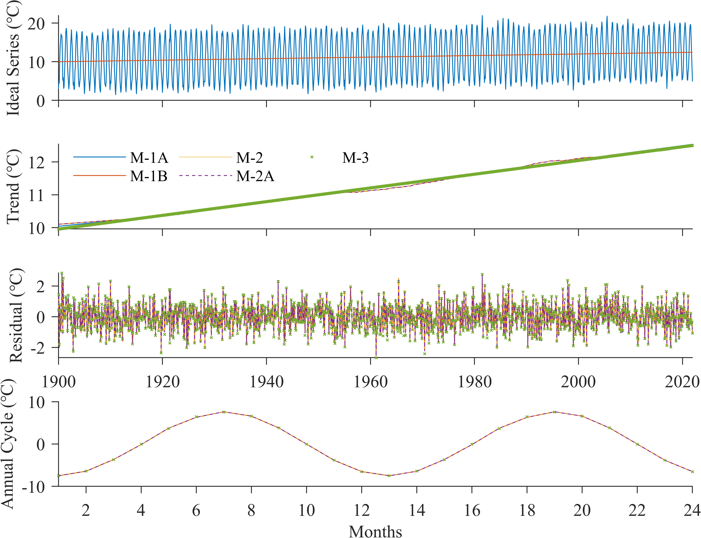

图1 理想试验Case 1. 理想时间序列(a)由线性趋势、以12个月为周期的seasonal components和Gaussian noise组成，(a)中红线展示其trend分量. 用三类方法分解出的trend分量示于(b)，Residual分量示于(c)，seasonal components示于(d).

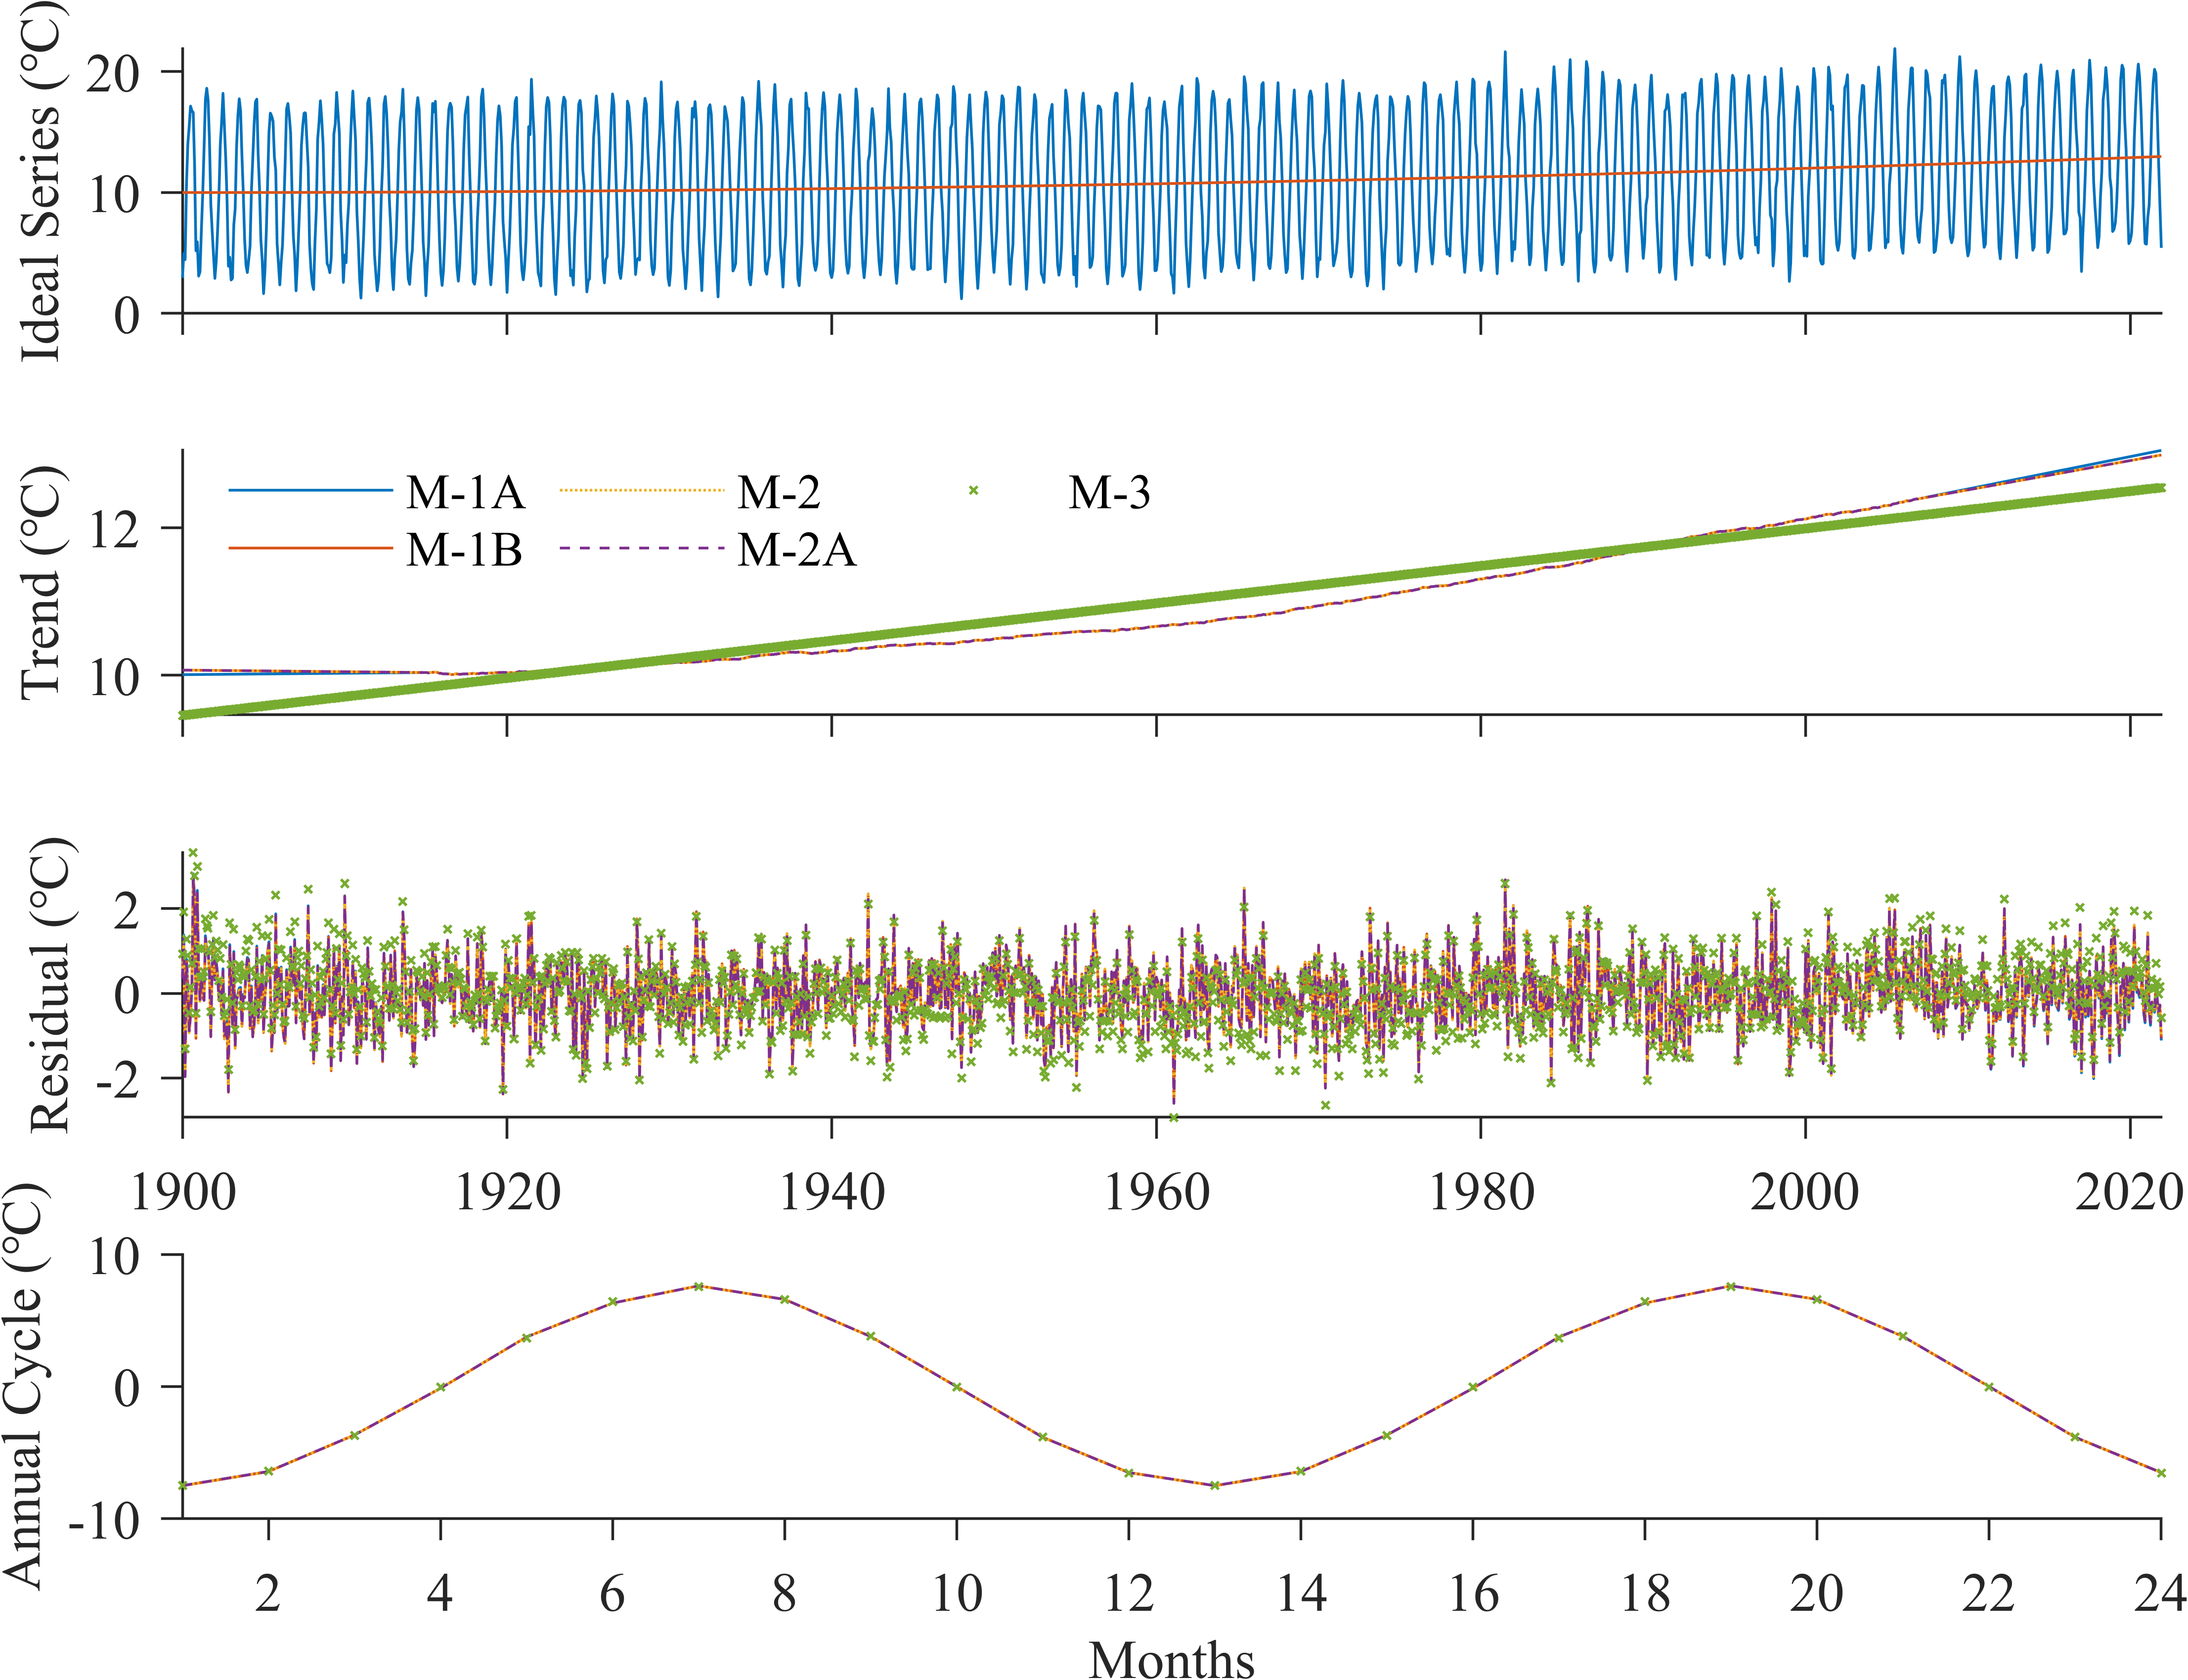

图2 理想试验Case 2. 理想时间序列(a)由二次多项式趋势、以12个月为周期的seasonal components和Gaussian noise组成，(a)中红线展示其trend分量. 用三类方法分解出的trend分量示于(b)，residual分量示于(c)，seasonal components示于(d).

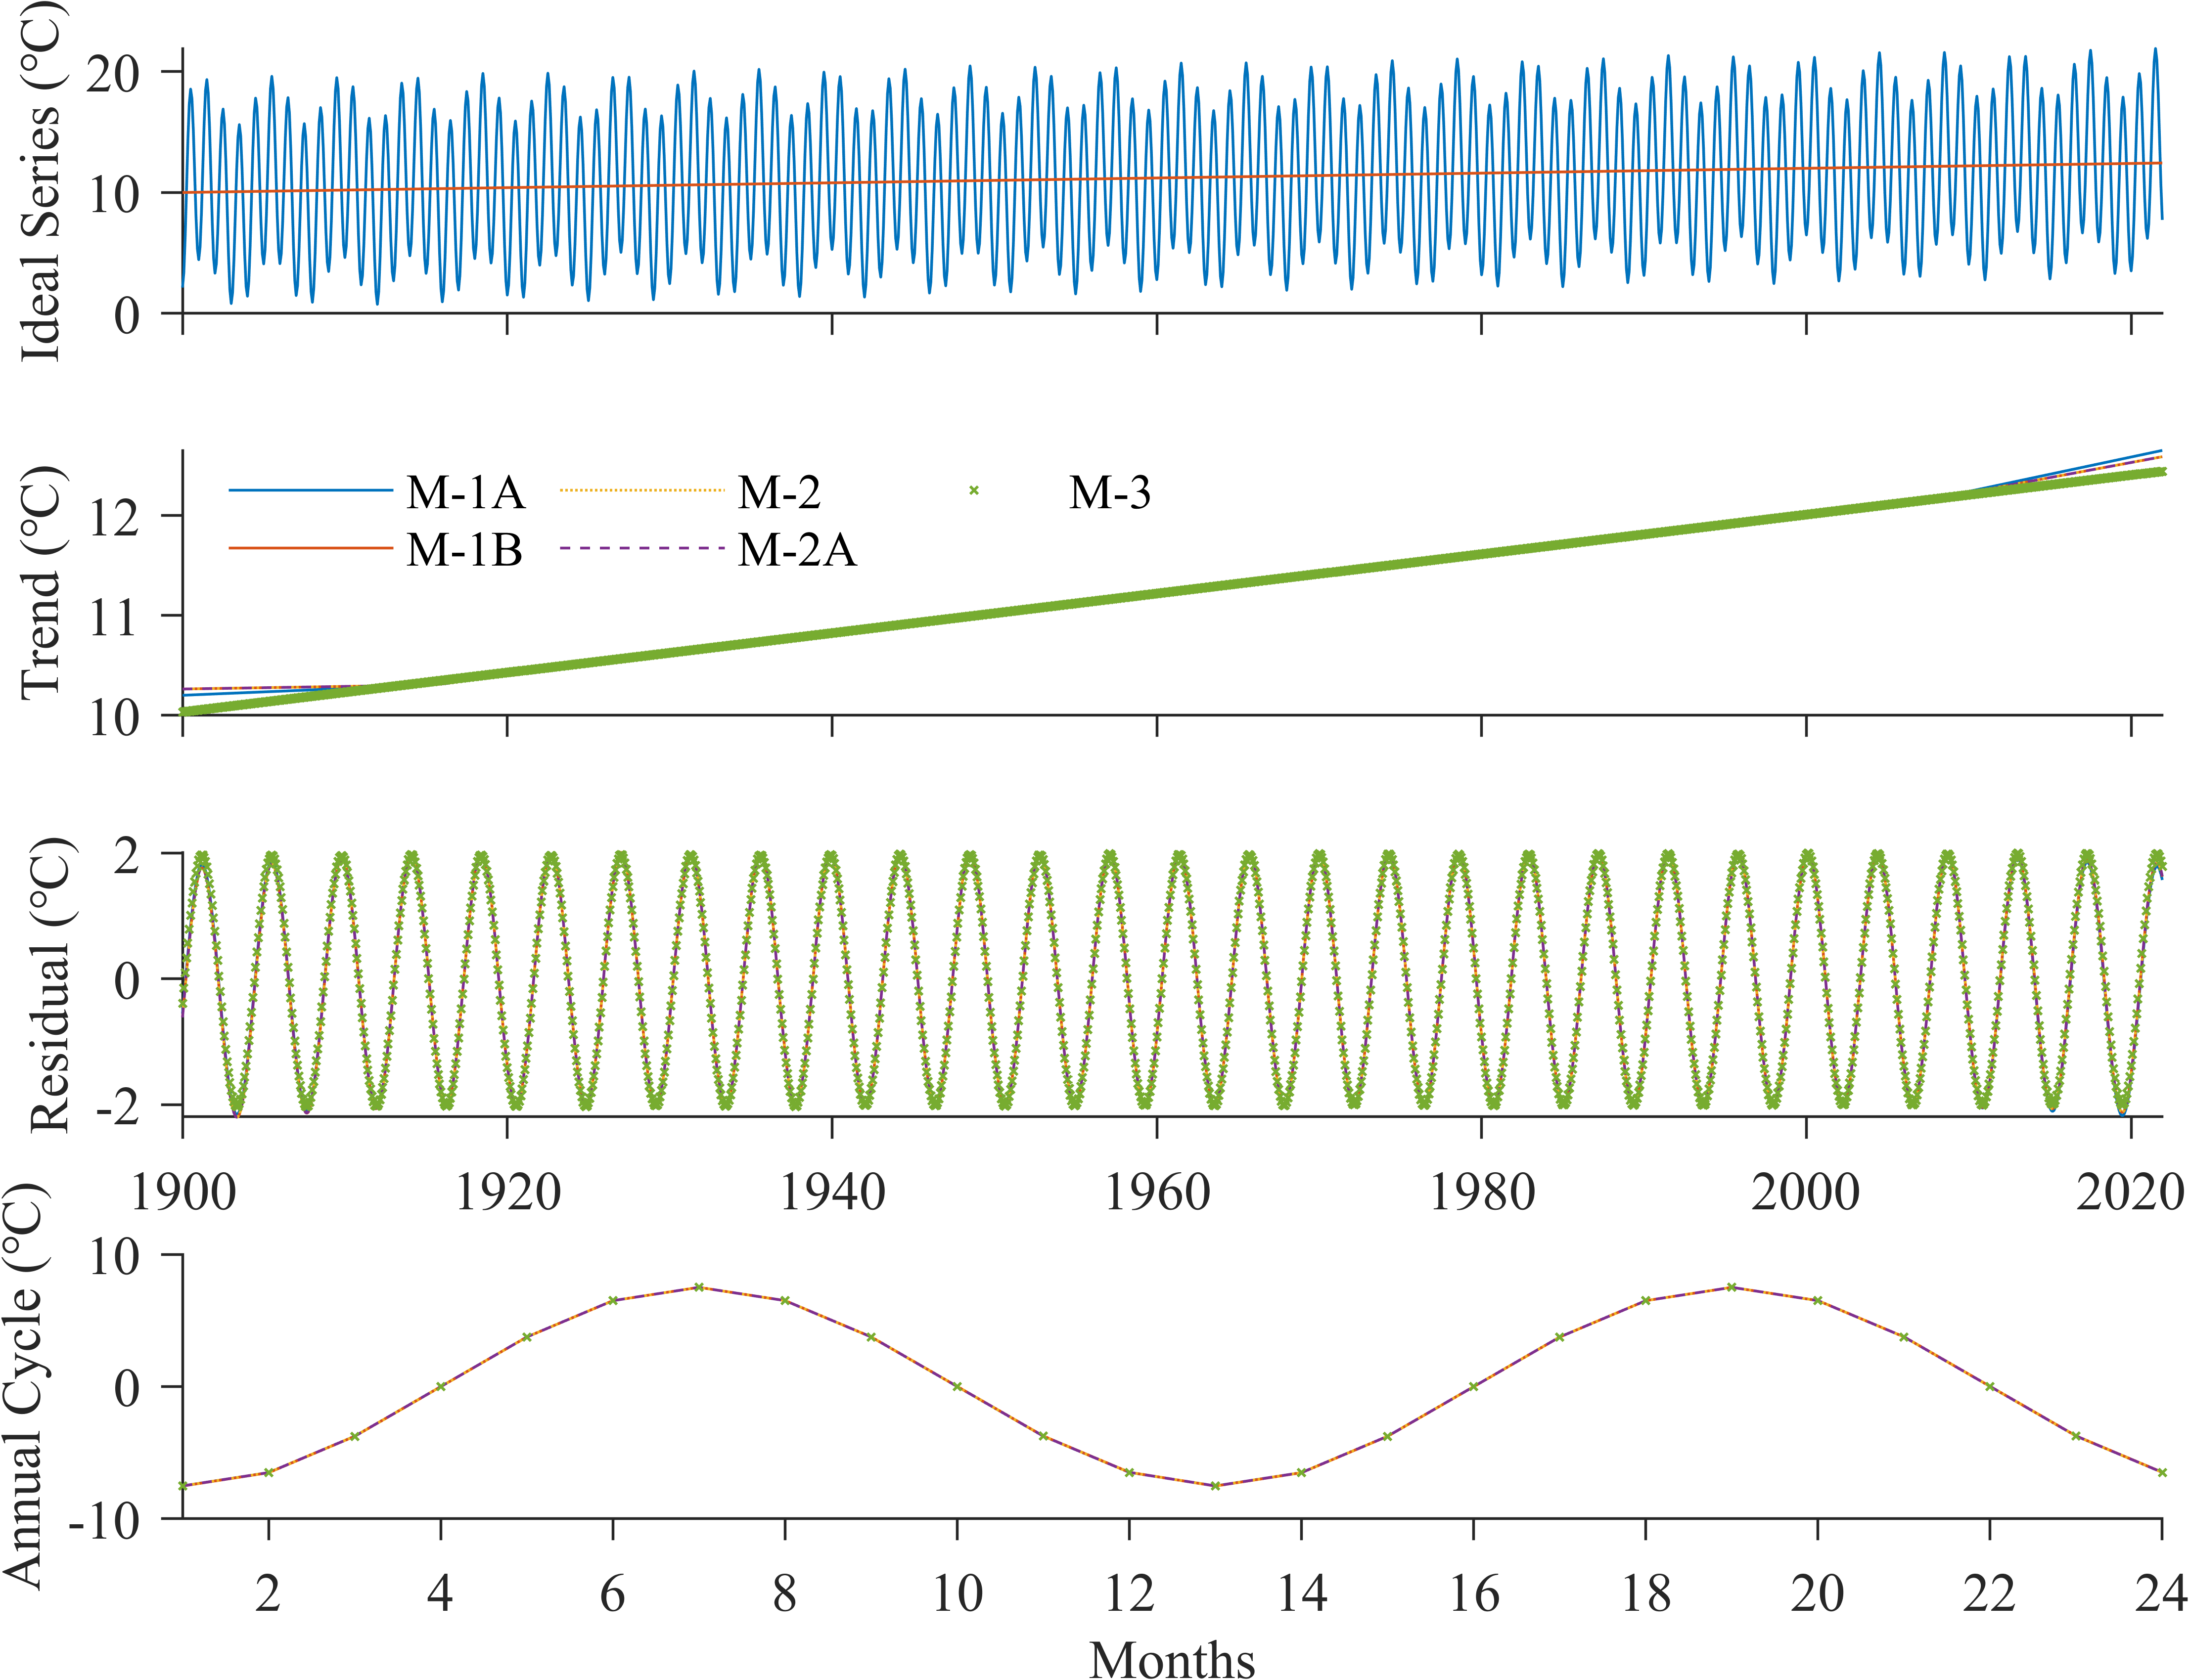

图3 理想试验Case 3. 理想时间序列(a)由线性趋势、以12个月为周期的seasonal components和以4.3年为周期的inter-annual变率组成，(a)中红线展示其trend分量. 用三类方法分解出的trend分量示于(b)，residual分量示于(c)，seasonal components示于(d).

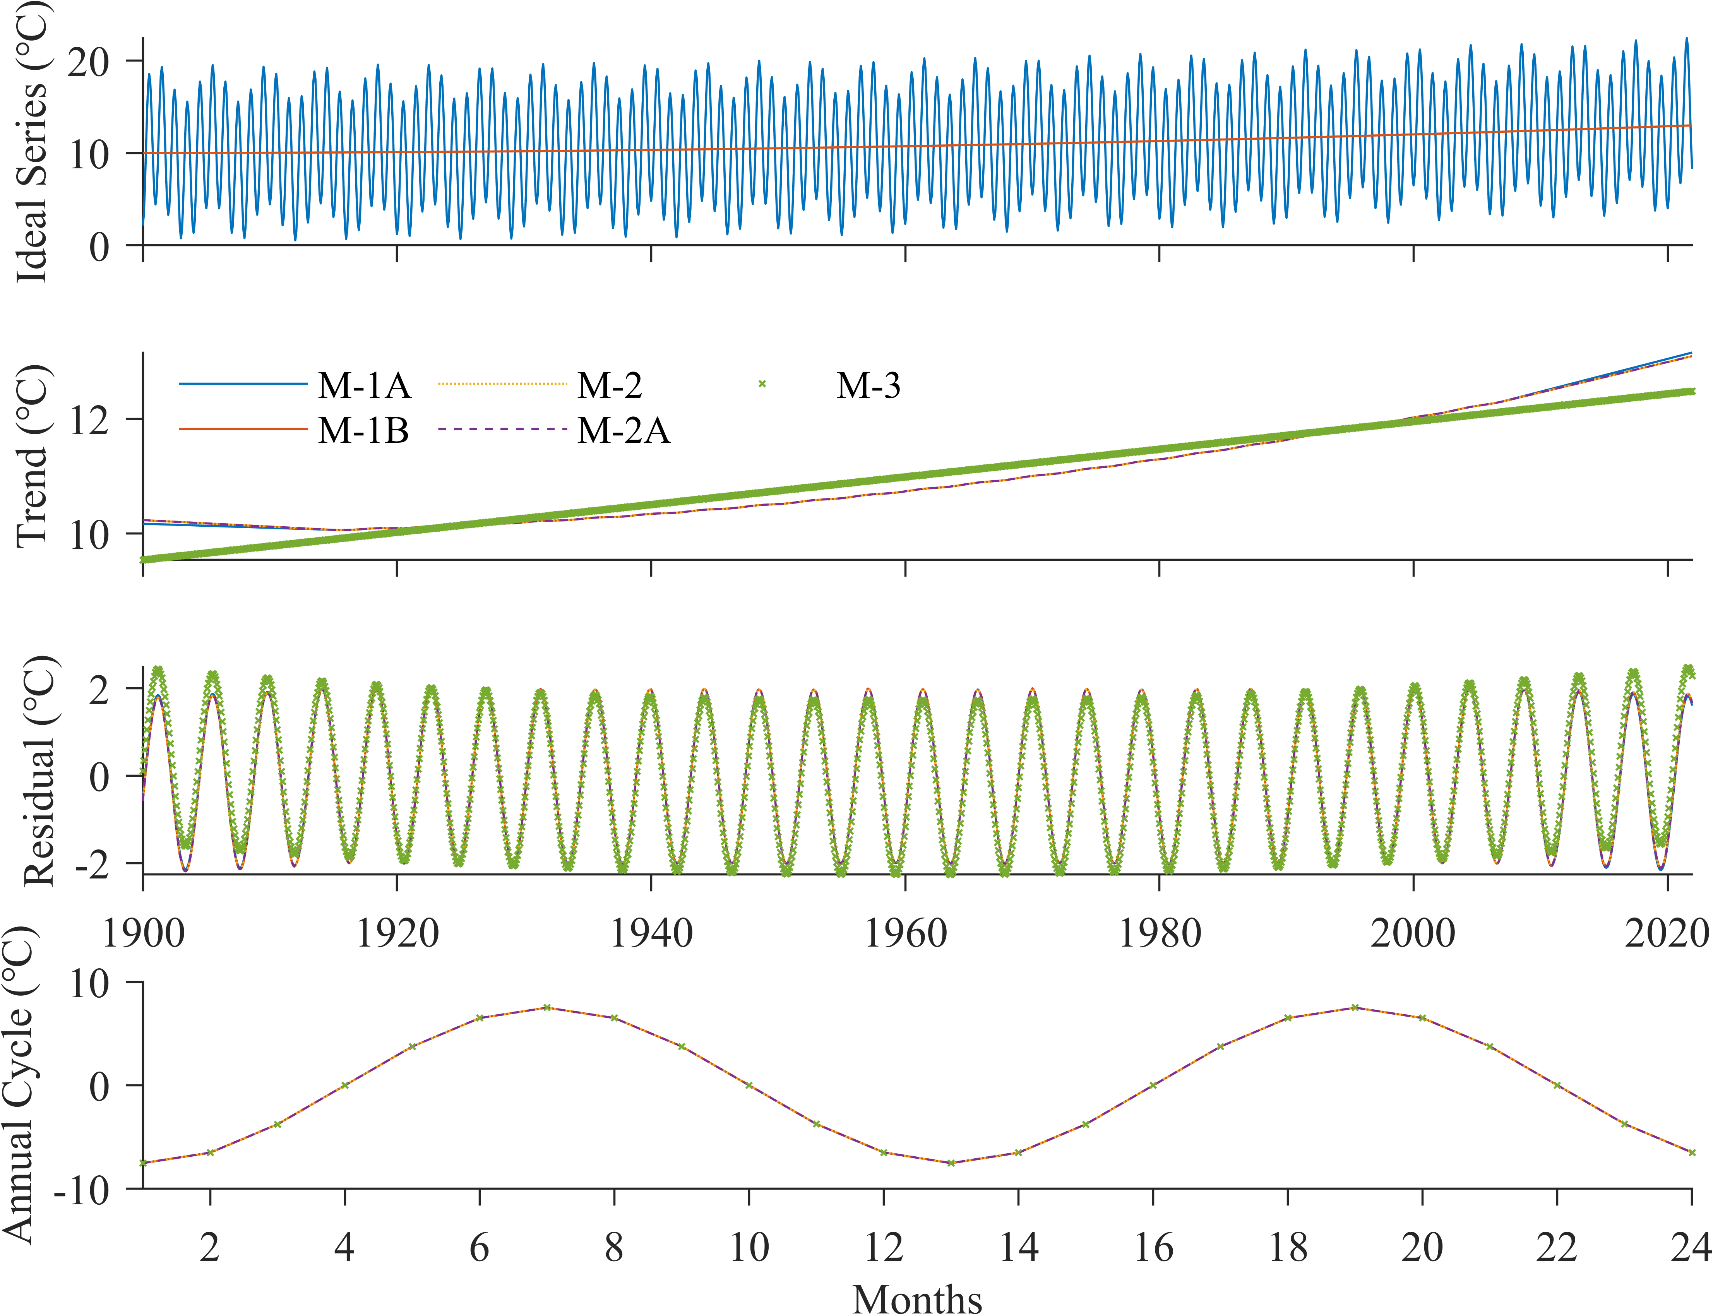

图4 理想试验Case 4. 理想时间序列(a)由二次多项式趋势、以12个月为周期的seasonal components和以4.3年为周期的inter-annual变率组成，(a)中红线展示其trend分量. 用三类方法分解出的trend分量示于(b)，residual分量示于(c)，seasonal components示于(d).

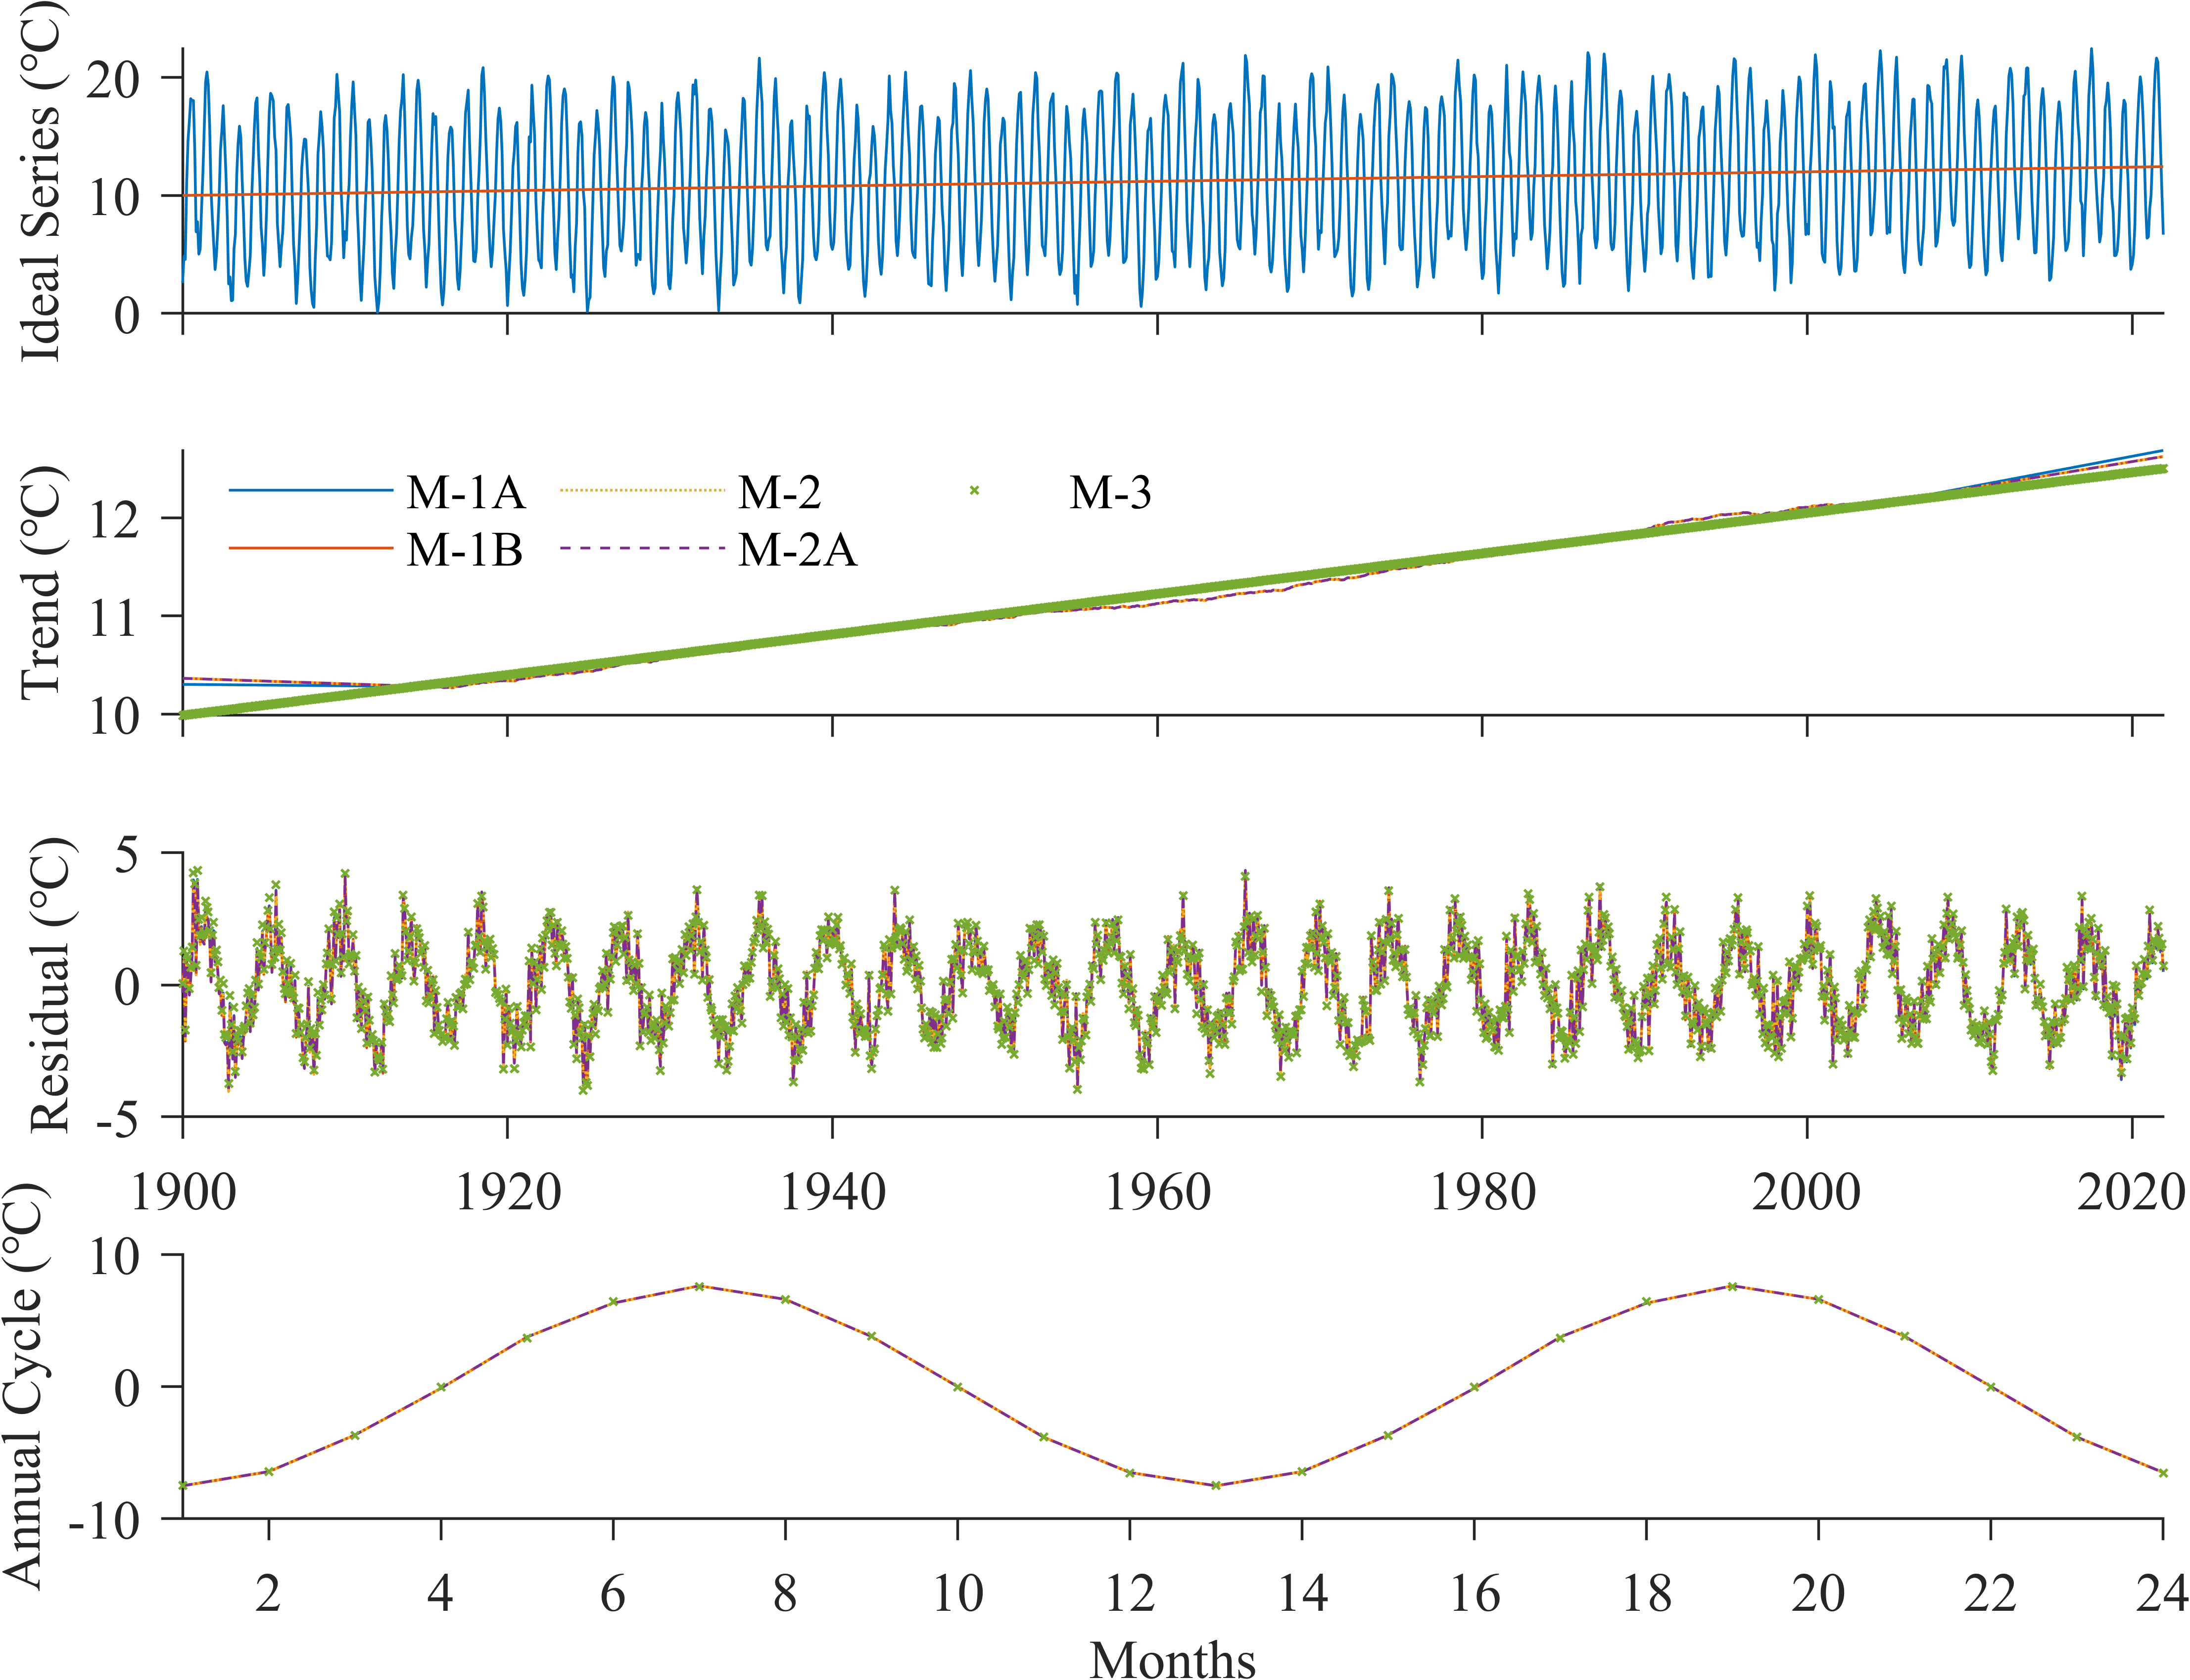

图5 理想试验Case 5. 理想时间序列(a)由线性趋势、以12个月为周期的seasonal components、以4.3年为周期的inter-annual变率和Gaussian noise组成，(a)中红线展示其trend分量. 用三类方法分解出的trend分量示于(b)，residual分量示于(c)，seasonal components示于(d).

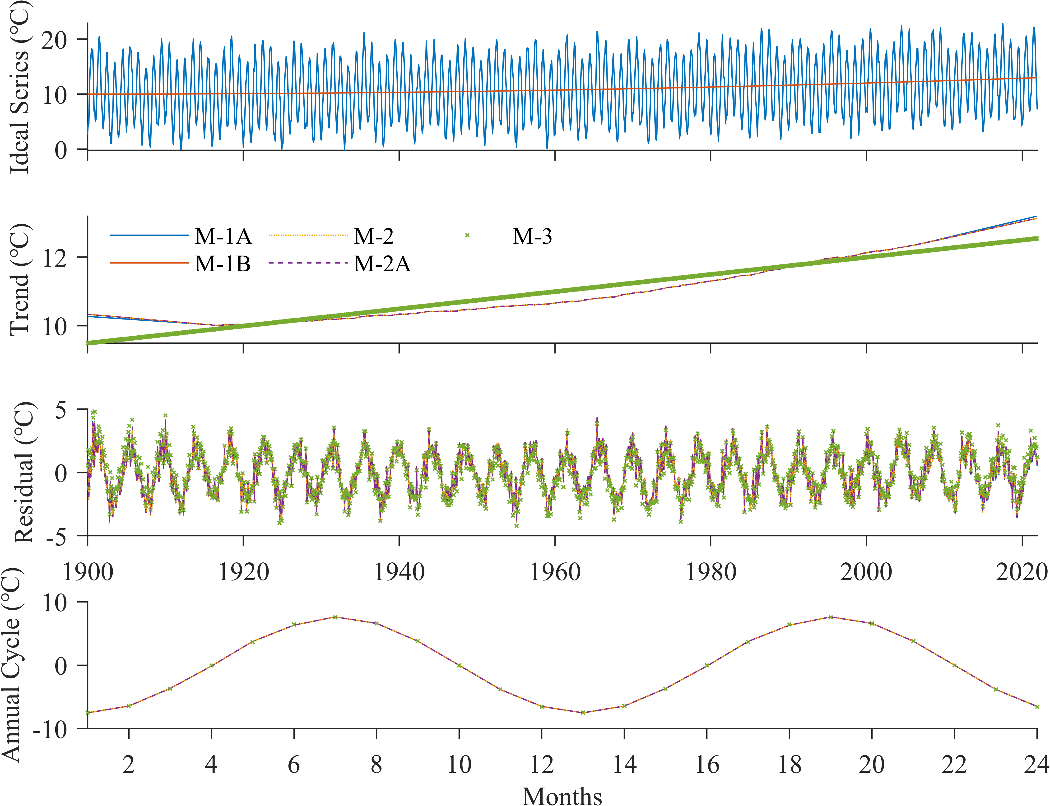

图6 理想试验Case 6. 理想时间序列(a)由二次多项式趋势、以12个月为周期的seasonal components、以4.3年为周期的inter-annual变率和Gaussian noise组成，(a)中红线展示其trend分量. 用三类方法分解出的trend分量示于(b)，residual分量示于(c)，seasonal components示于(d).

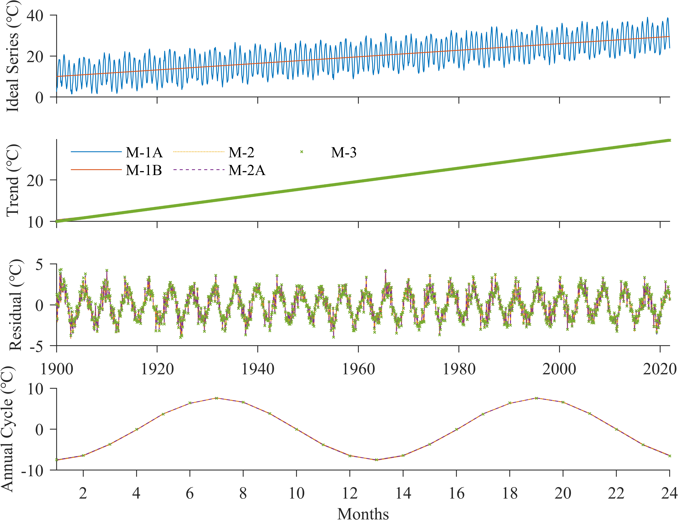

图7 理想试验Case 7. 理想时间序列(a)由剧烈的线性趋势、以12个月为周期的seasonal components、以4.3年为周期的inter-annual变率和Gaussian noise组成，(a)中红线展示其trend分量. 用三类方法分解出的trend分量示于(b)，residual分量示于(c)，seasonal components示于(d).

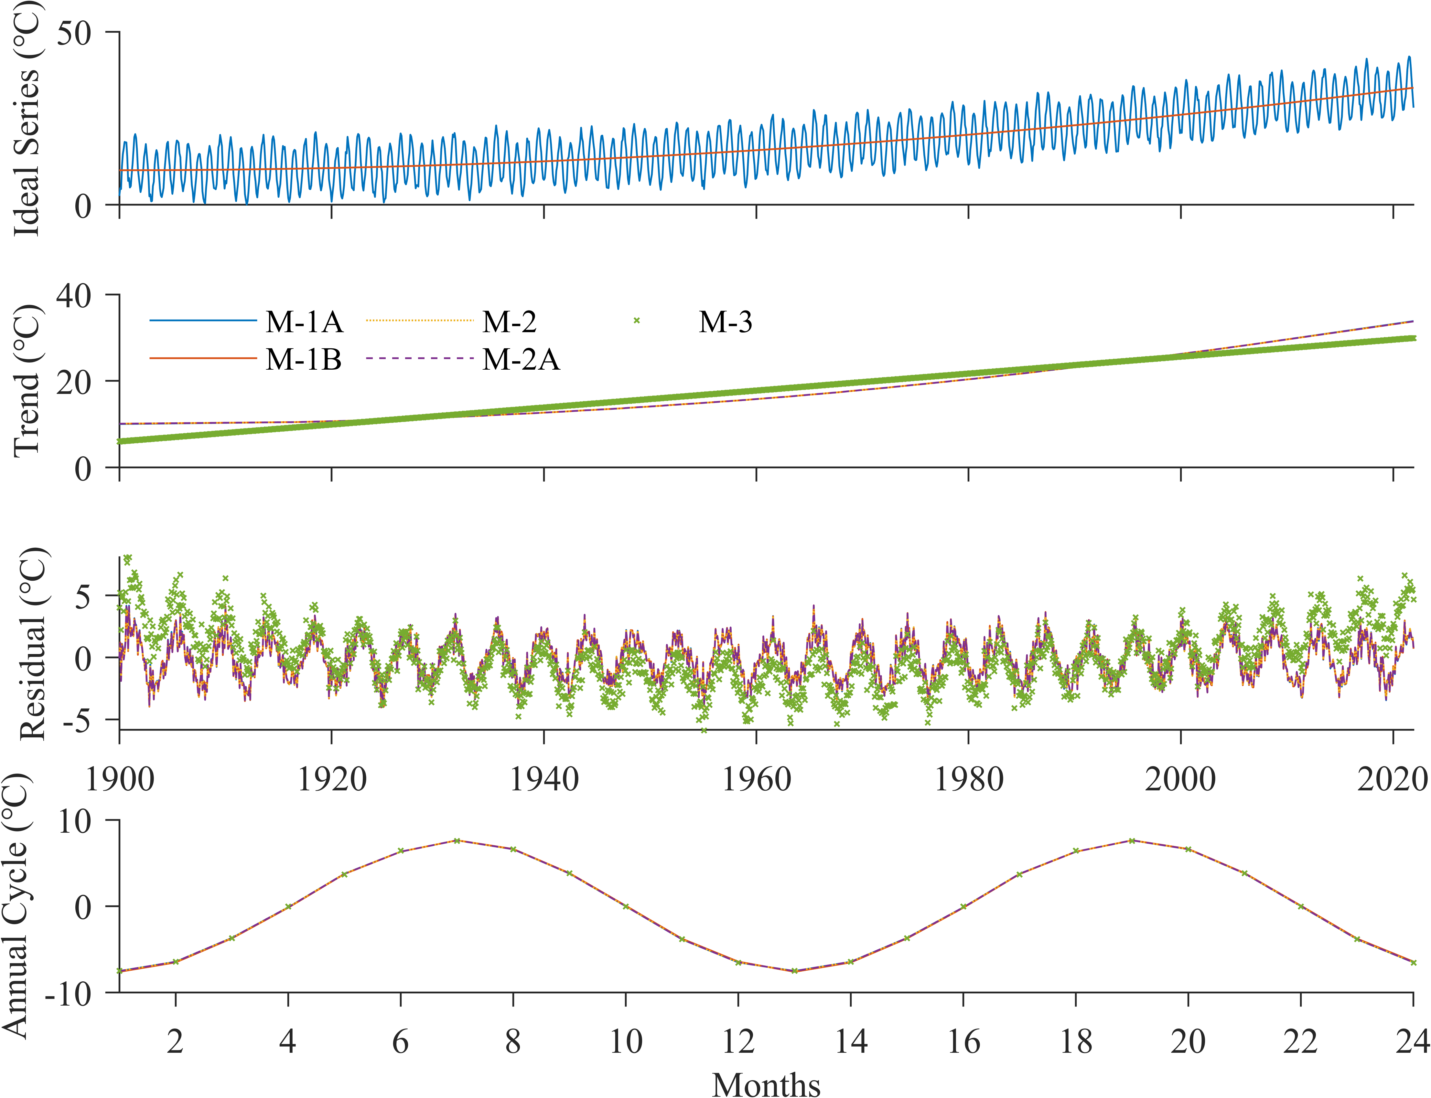

图8 理想试验Case 8. 理想时间序列(a)由剧烈的二次多项式趋势、以12个月为周期的seasonal components、以4.3年为周期的inter-annual变率和Gaussian noise组成，(a)中红线展示其trend分量. 用三类方法分解出的trend分量示于(b)，residual分量示于(c)，seasonal components示于(d).

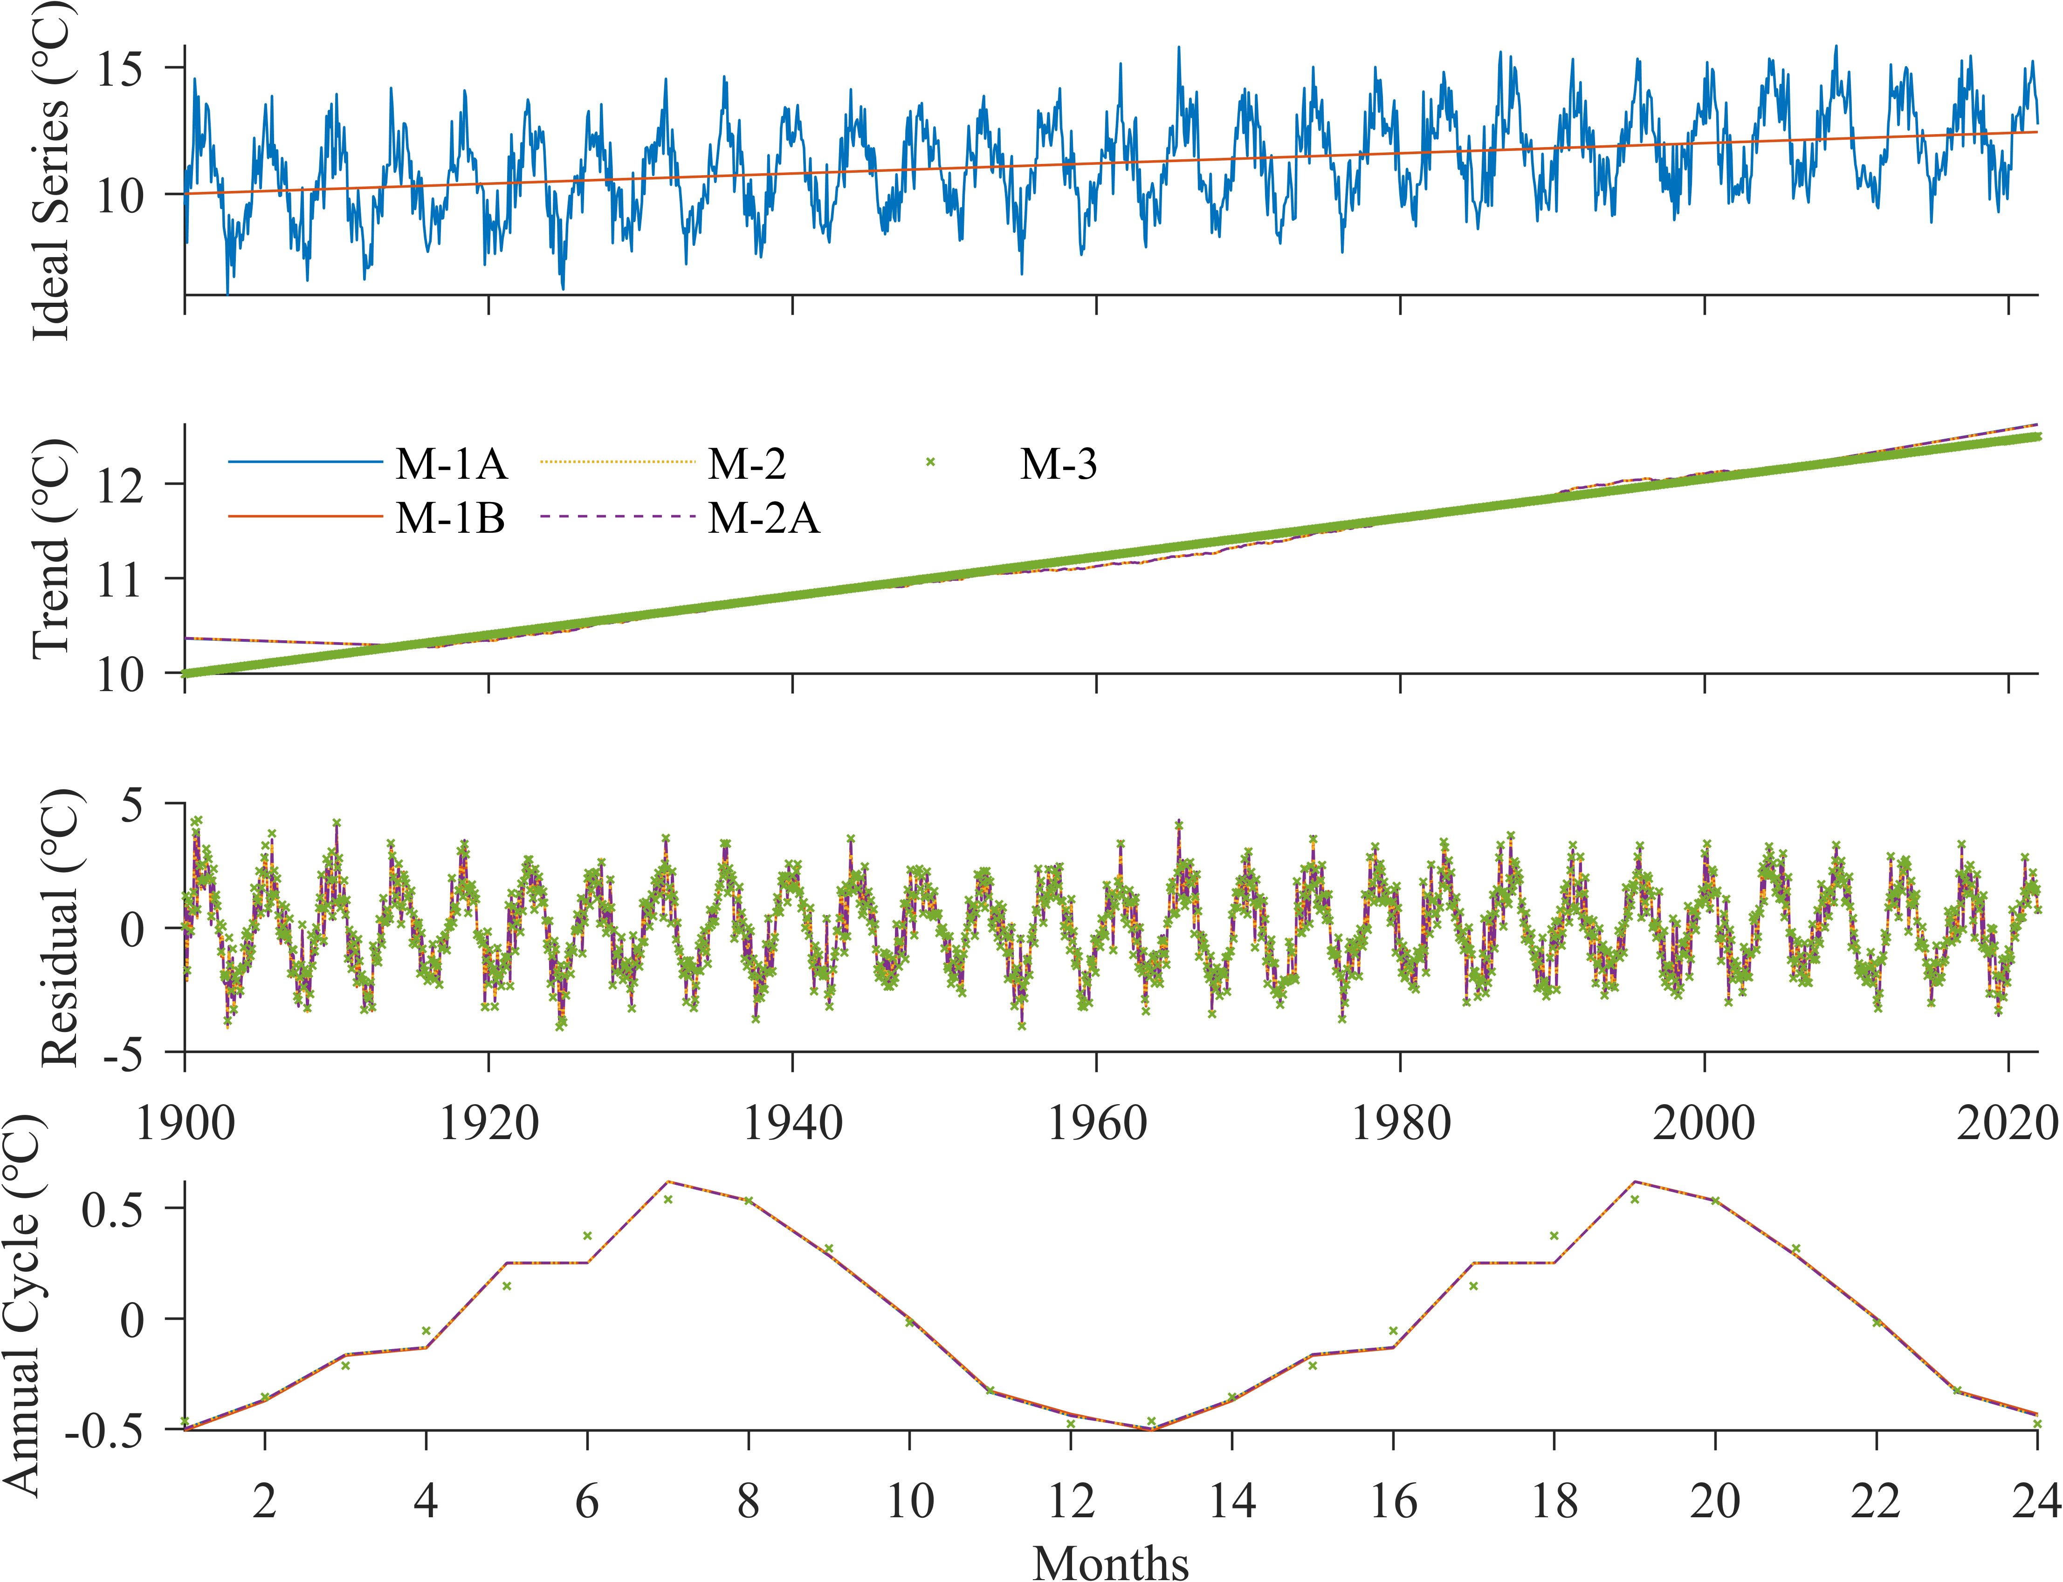

图9 理想试验Case 9. 理想时间序列(a)由线性趋势、以12个月为周期的微弱seasonal components、以4.3年为周期的inter-annual变率和Gaussian noise组成，(a)中红线展示其trend分量. 用三类方法分解出的trend分量示于(b)，residual分量示于(c)，seasonal components示于(d).

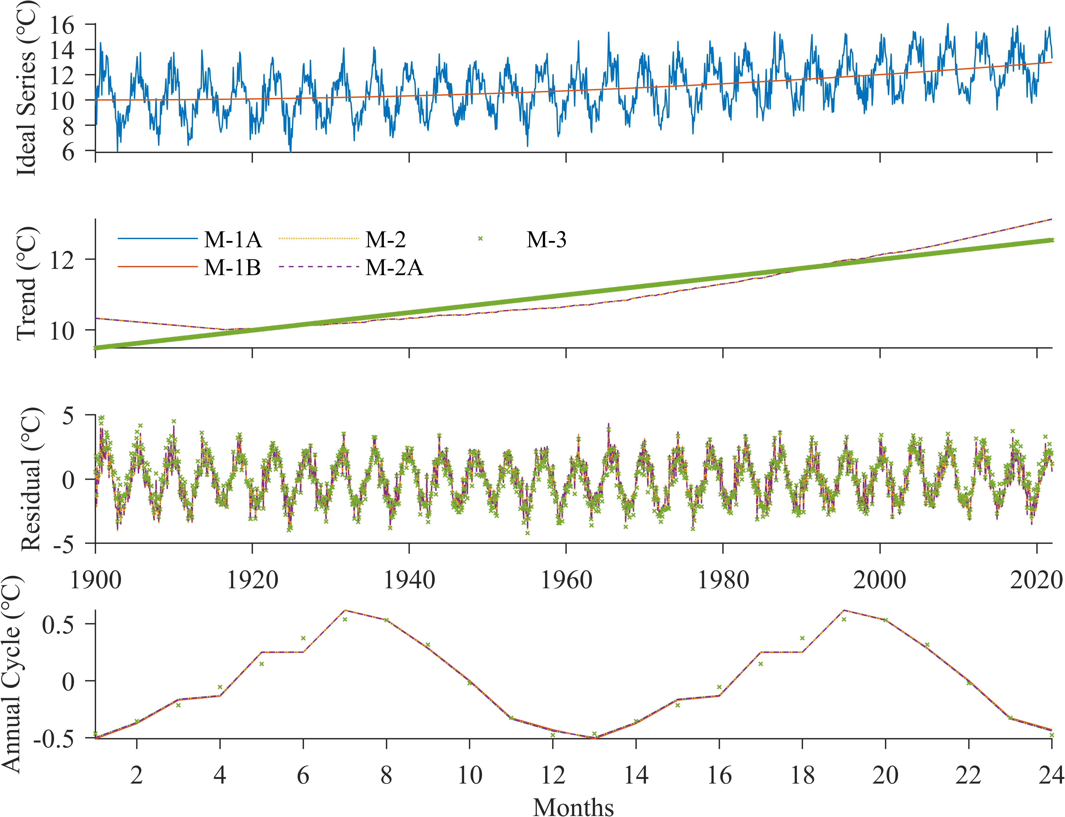

图10 理想试验Case 10. 理想时间序列(a)由二次多项式趋势、以12个月为周期的微弱seasonal components、以4.3年为周期的inter-annual变率和Gaussian noise组成，(a)中红线展示其trend分量. 用三类方法分解出的trend分量示于(b)，residual分量示于(c)，seasonal components示于(d).

### comparison of different methods

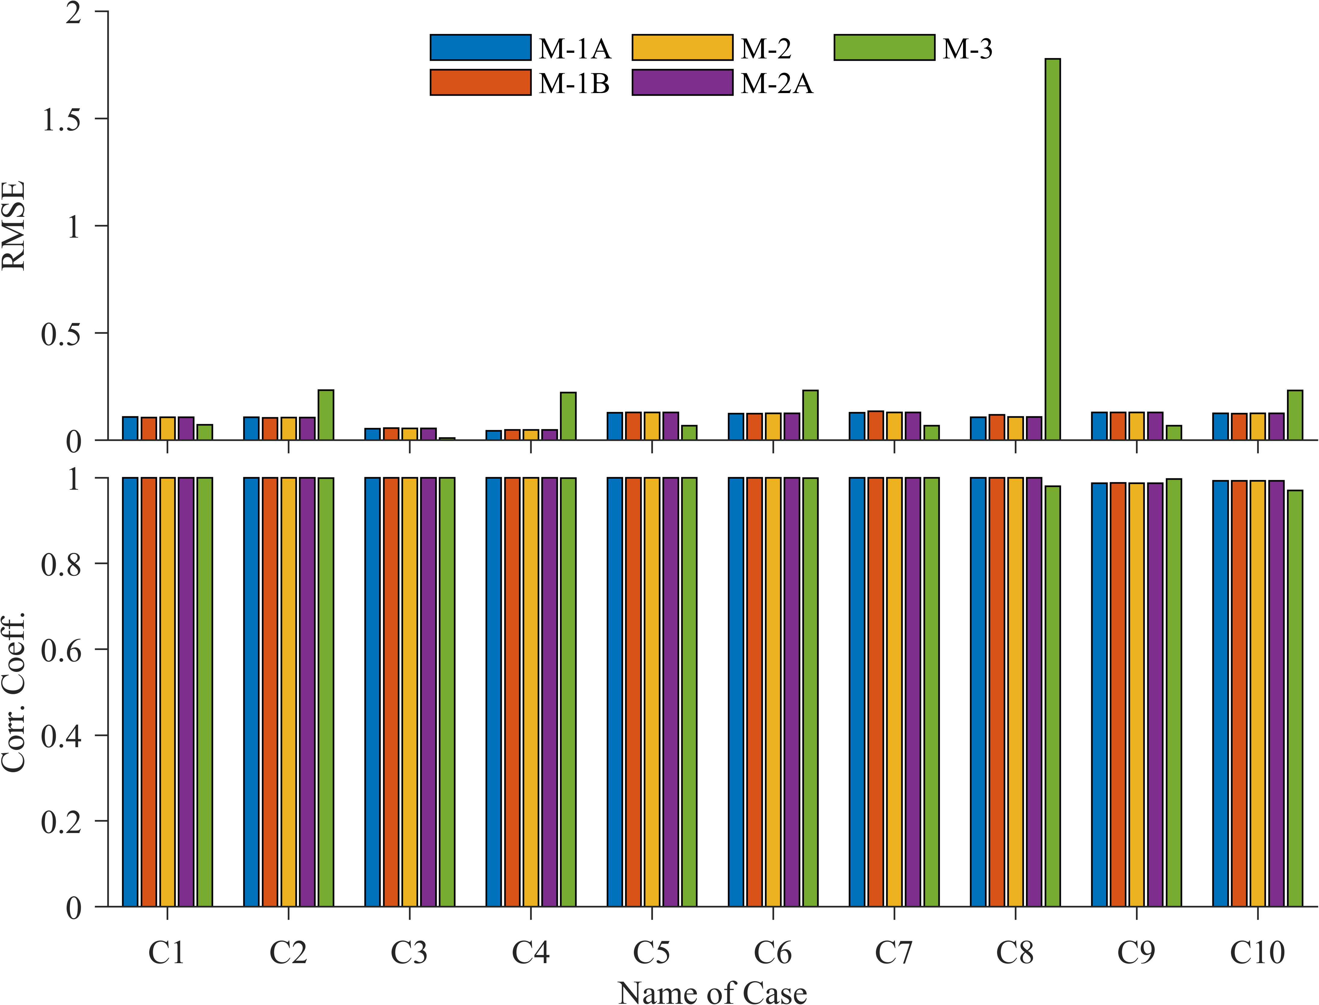

图11 在理想试验中，三类classical decomposition methods输出的气候平均态（trend + seasonal components）对理想时间序列中气候平均态的样本均方根误差(RMSE)和Pearson线性相关系数(CC).

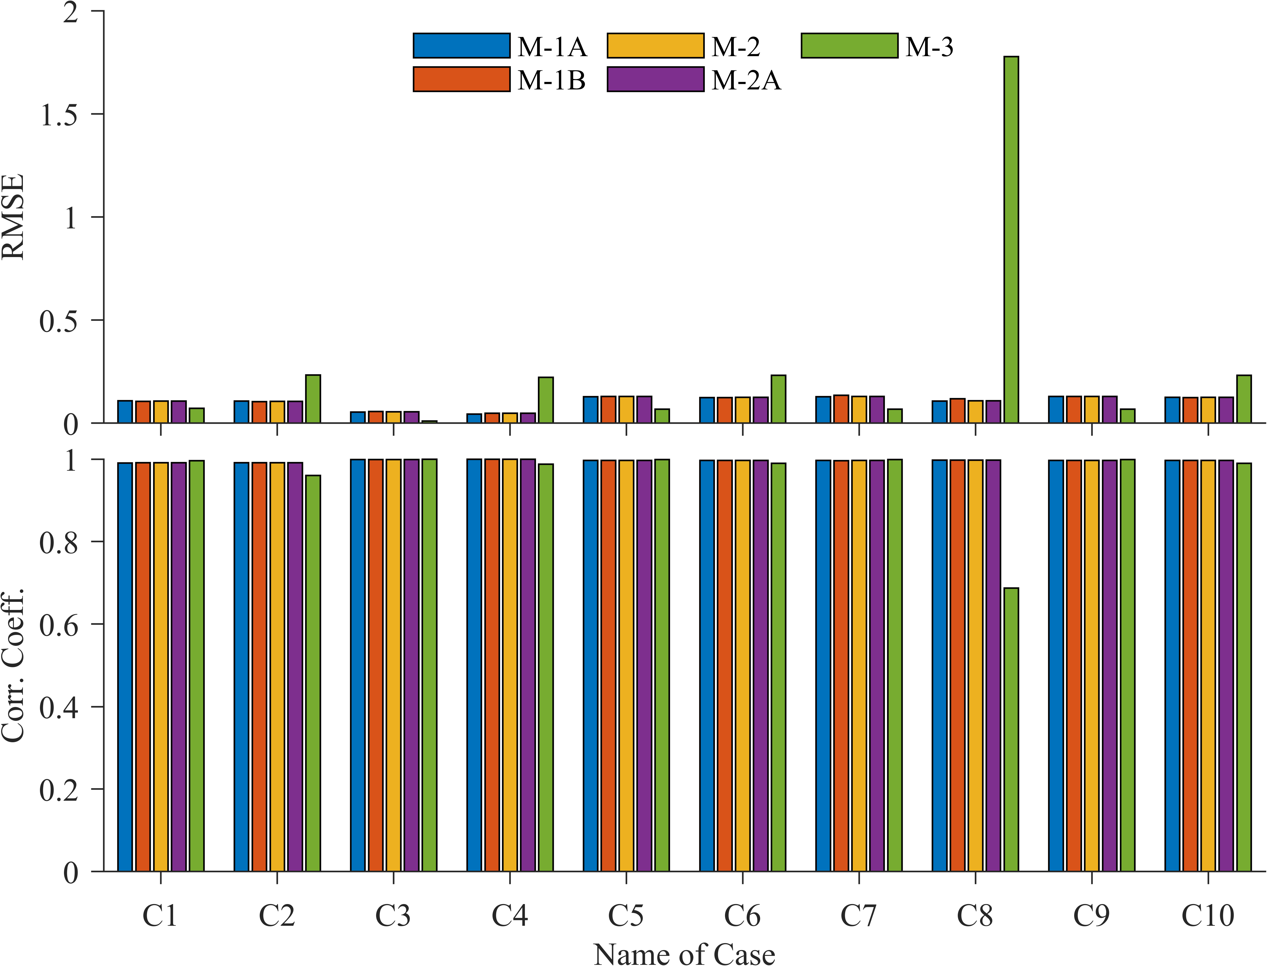

图12 在理想试验中，三类classical decomposition methods输出的residual分量对理想时间序列中residual分量的样本均方根误差(RMSE)和Pearson线性相关系数(CC).

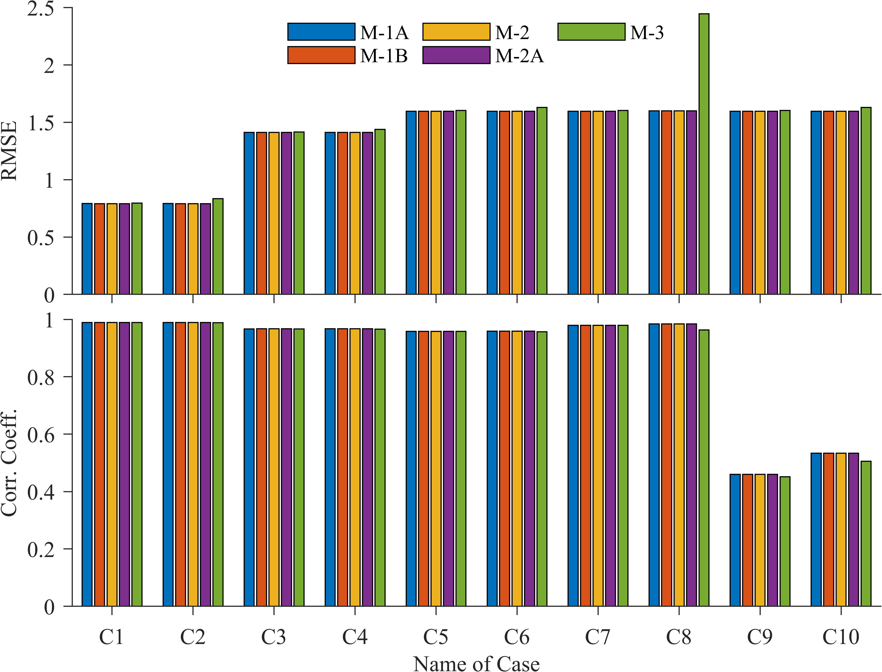

图13 在理想试验中，三类classical decomposition methods输出的气候平均态（trend + seasonal components）对理想时间序列的样本均方根误差(RMSE)和Pearson线性相关系数(CC).

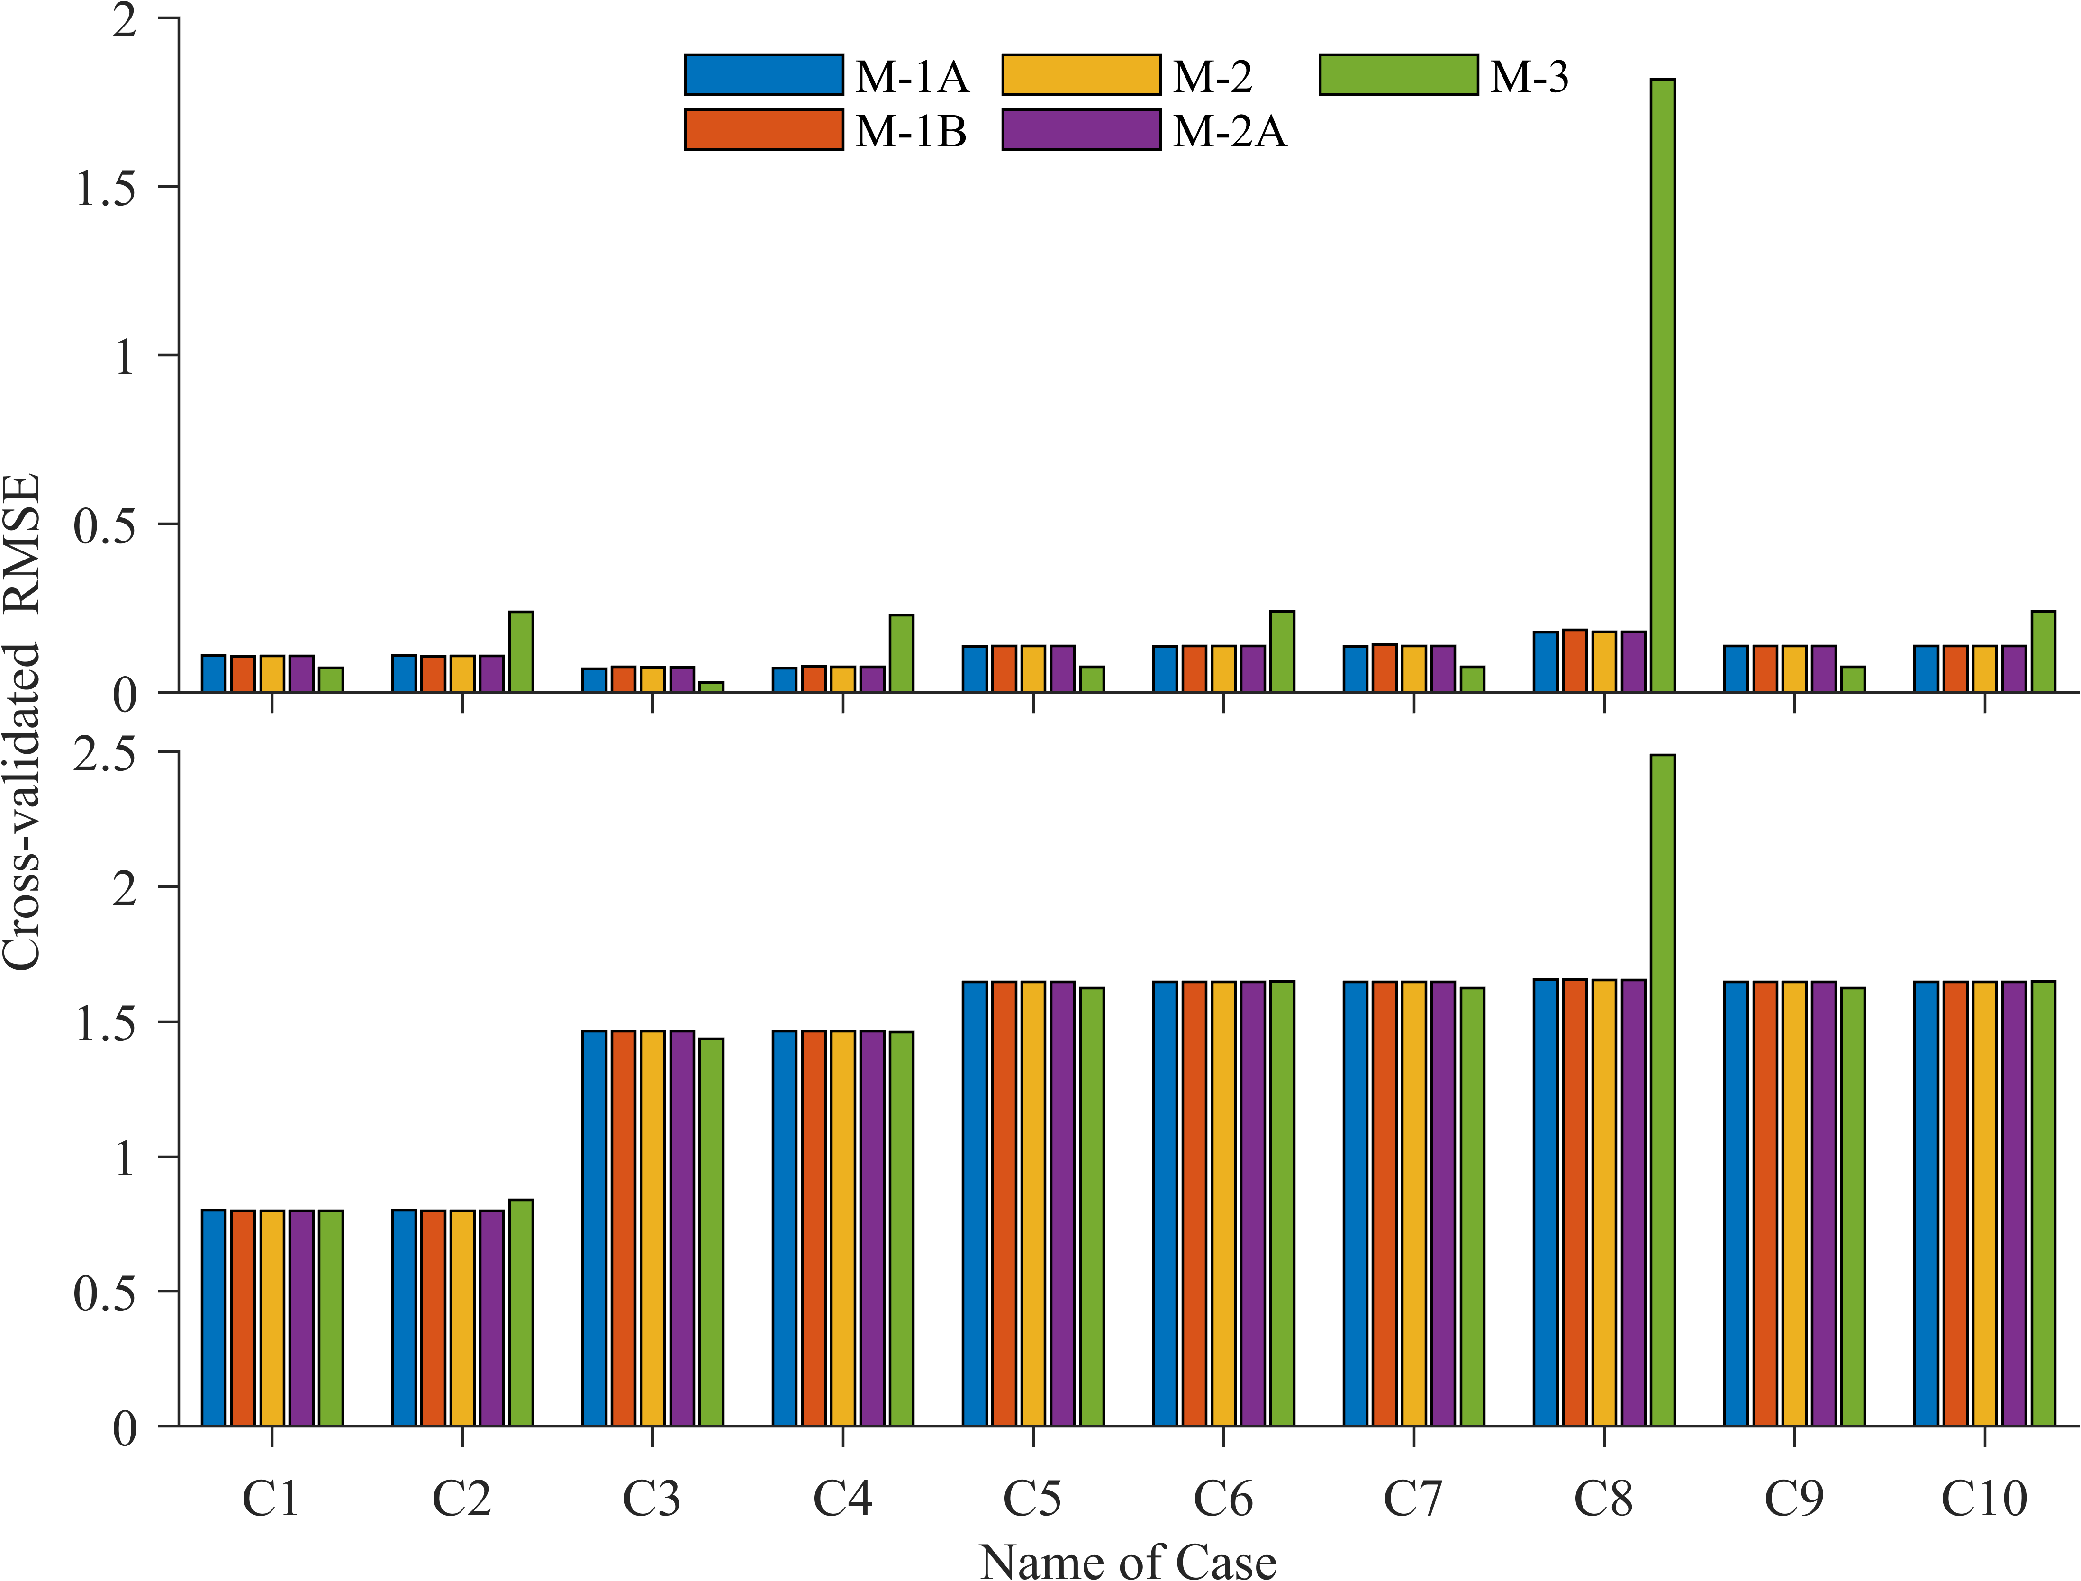

图14 在理想试验中，三类classical decomposition methods输出的气候平均态（trend + seasonal components）对理想时间序列(b)及其气候平均态(a)的交叉验证均方根误差(CVE).

## Classical decomposition of several real time-indices

# Conclusions

本文以三种常用的经典分解方案为例，研究了不同的分解方案对结果的影响. 结果表明，采取不同的分解方法，对结果会造成一定的影响. 在某些情况(趋势强非线性，趋势增量大，季节信号的解释方差小?)下，影响更明显. 在全球气候变化的背景下，本文的结果值得学界关注.

基于本文的讨论，我们认为，气候态(包括长期趋势，季节周期分量等)应是客观的，但趋势和季节周期的定义，以及相应的分解方案及其参数的选取却带有主观性，这是分解方案选取问题的根源. 因此，我们对后续研究提出以下建议：(1) 后续研究应对气候态各分量建立客观定义，并建立相应的自适应分解方案. (2) 在对气候事件的分类和讨论中，若使用了某种时间序列分解方法，则应增加讨论采取其他分解方法对结果的影响，以避免研究结论被分解方案选取带来的虚假变率误导.

# References

Chen, X., & Li, T. (2021). An Improved Method for Defining Short-Term Climate Anomalies. *Journal of Meteorological Research*, *35*(6), 1012-1022. <https://doi.org/10.1007/s13351-021-1139-2>

Findley, D. F., Monsell, B. C., Bell, W. R., Otto, M. C., & Chen, B.-C. (1998). New Capabilities and Methods of the X-12-ARIMA Seasonal-Adjustment Program. *Journal of Business & Economic Statistics*, *16*(2), 127-152. <https://doi.org/10.1080/07350015.1998.10524743>

Narapusetty, B., DelSole, T., & Tippett, M. K. (2009). Optimal Estimation of the Climatological Mean. *Journal of Climate*, *22*(18), 4845-4859. <https://doi.org/10.1175/2009jcli2944.1>

Pezzulli, S., Stephenson, D. B., & Hannachi, A. (2005). The Variability of Seasonality. *Journal of Climate*, *18*(1), 71-88. <https://doi.org/10.1175/jcli-3256.1>

Wu, Z., Huang, N. E., Long, S. R., & Peng, C.-K. (2007). On the trend, detrending, and variability of nonlinear and nonstationary time series. *Proceedings of the National Academy of Sciences*, *104*(38), 14889-14894. <https://doi.org/10.1073/pnas.0701020104>